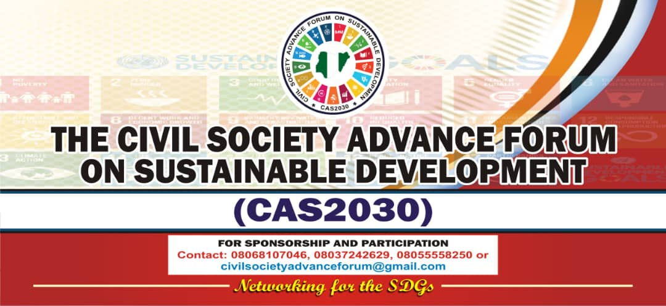
The Civil Society Advance Forum on Sustainable Development (CAS2030) is a not-for-profit, non-partisan, national platform and alliance of Civil Society organizations working towards the achievement of the SDGs and the agenda 2030 in Nigeria.

The alliance has membership strength of over 2000 NGOs across the 36 states in Nigeria. And it’s a member of the National Civil Society Strategy Group ( CSOSG) currently serving in the exco.

When was our organization formed?

The Alliance was formed on 1st of August, 2017, duly registered with corporate Affairs Commission reg. No. CAC/IT/NO. 102044

Who started the organization and why?

A group of Civil Society organizations from across Nigeria came together to form an alliance for the monitoring and implementation of the SDGs.

The High Level Political Forum on SDGs held in New York, July 2017 revealed the need for a more engaging and inclusive platform for CSOs in Nigeria to engage the sustainable development agenda.

During the course of the HLPF 2017, CSOs committed themselves to undertaking actions that have the potential to shape the future of people through the implementation of the SDGs.
While there are mixed views in civil society about whether the 2030 development agenda can deliver on ending poverty, ending hunger, achieving food security, improving nutrition, ensuring healthy lives and promoting well-being, promoting gender equality, ensuring environmental sustainability among other things, it was unanimously resolved that civil society needs to play an active role in keeping the spotlight on these commitments, working on implementation, and holding the leaders accountable for the actualization of the goals.
While our process of mobilization has revealed widespread enthusiasm, It was felt that a new national platform is critical to achieving added value to civil society initiatives on sustainable development.

Our Work
CAS2030 work to provide a space to share resources and strategies for advocacy, policy, programmes and mobilisation and facilitate collaboration amongst civil society actors and other development partners.

Vision
To build solidarity among organizations across the country and build linkages between local organizations, National and International level organizations.

Mission:
To harness the positive energy created through civil society initiatives and build a strong and inclusive platform to connect and support civil society activities on sustainable development at all levels (local, national, regional and global).

AIM
CAS2030 aims to engage with the sustainable development agenda and commits to collectively empower the marginalized and vulnerable persons to campaign against hunger, inequality and injustice.

Thematic Focus
- Advocacy, Awareness and Sensitization- Raising pubic awareness of the SDGs among ciizens and all stakeholders, especially in the communities that are left behind
- Accountability and Governance – Empowering people with information to help engage others and to hold their government accountable
- Impact: taking Individual organizations actions and / or unite with others to make a lasting change towards SDG achievements, like local projects
- Governance, Conflict mediation, Peace and Security
- Monitoring of the SDGs implementation at all levels

ORGANIZATION OBJECTIVES:
- To contribute to the achievement of Sustainable Development Goals (SDGs) through research, advocacy and education for all.
- To develop and provide new knowledge and promote the uptake of development policies that will address the issues of the Sustainable Development Goals (SDGs).
- To advocate, evaluate and facilitate responses for the Sustainable Development Goals, to meet the need of all sectors of society, particularly the most vulnerable and marginalized.
- To promote and strengthen the underlying principles of the Global Goals and targets of the Sustainable Development Goals (SDGs) through collaborative efforts of civil societies at National, Regional and International levels
- To create a sense of corporation, mutual harmony and affection amongst the members of the forum

WHAT HAVE WE DONE / ACCOMPLISHED
- Localizing the SDGs in Nigeria: The Role of CSOs and other Key Actors
1st National Conference on Sustainable Development Goals (SDGs) in Abuja, Nigeria
August, 1, 2018
- The Conference aims to unravel the potential roles of CSOs and other key actors in the effective implementation of the SDGs in Nigeria
- Seeks to enhance their engagement, impact and effectiveness in global development processes

- Highlighted key points and drew the roadmap towards achieving the SDGs in the 36 states of the federation
350 participants from across Nigeria participated

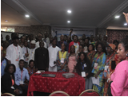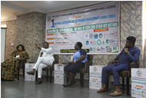

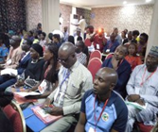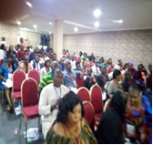
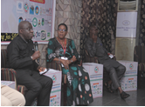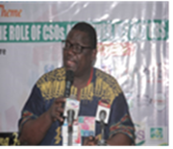

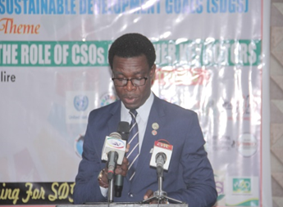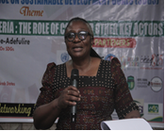

- Localizing the SDGs in Nigeria: Partnerships that Works
2nd National Conference on Sustainable Development Goals (SDGs) in Abuja, Nigeria
August 1, 2019
- Building on the 1st National conference and in a bid towards robust Partnerships that work for the attainment of the SDGs in Nigeria
- Civil Societies saw the need for actors to come together again, and chart the course for the SDGs in Nigeria
- The conference Brought a wide range of participants (312) from Civil Society, OSSAP –SDGs, Academia, embassies, media, Key Government Ministries and Agencies, State Governments, including grassroots organizations together
- The Conference featured Exhibitions and Expo to showcase solutions that offers participants opportunity to put a local perspective on achieving the SDG’s in Nigeria
- Local organizations pitch their SDGs projects
- Networking and Interface with the private sector and the Government / state SDG’s
- Participants gained insights into opportunities that might exist to partner towards achieving the SDG’s in the state and our local communities.

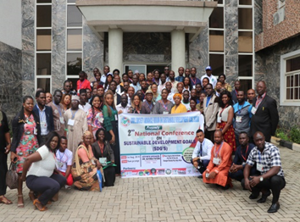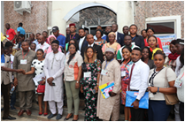

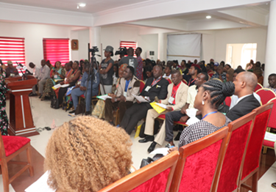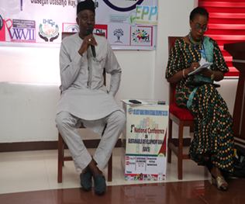

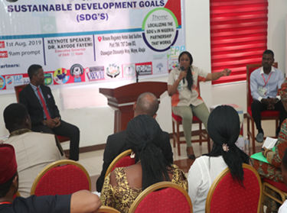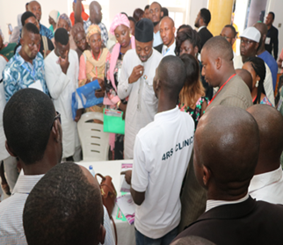

- Localizing the SDGs in Nigeria: Making a case for Delta State
We have carried our several Advocacy visits to state SDGs as well as Local Governments councils…
- For creation of SDGs desk officers
- Develop a document for clear policy direction
Advocate for an action plan and a road map for driving the SDGs at all levels in Nigeria.

CSOs are currently doing massive awareness and sensitization campaigns using the CAS2030 handbook and other resource materials to engage local communities and educate citizens about the SDGs.
Roundtable discussions on Sustainable Development Goals (SDGs) in Delta, Bayelsa Rivers and other States in commemoration of the Global Day Of Action for SDGs at 3, #ACT4SDGS in Nigeria. 25th September 2018

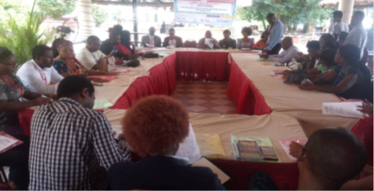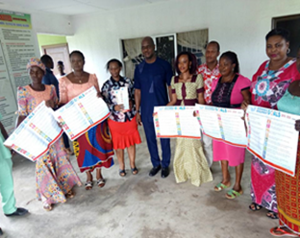

- Peace, Justice and Strong Institutions

Street March for Justice for Elozino
We took to the street to demand justice for Elozino a Vibrant student of Delta State University Abraka who was Brutally Killed by Ritualist.
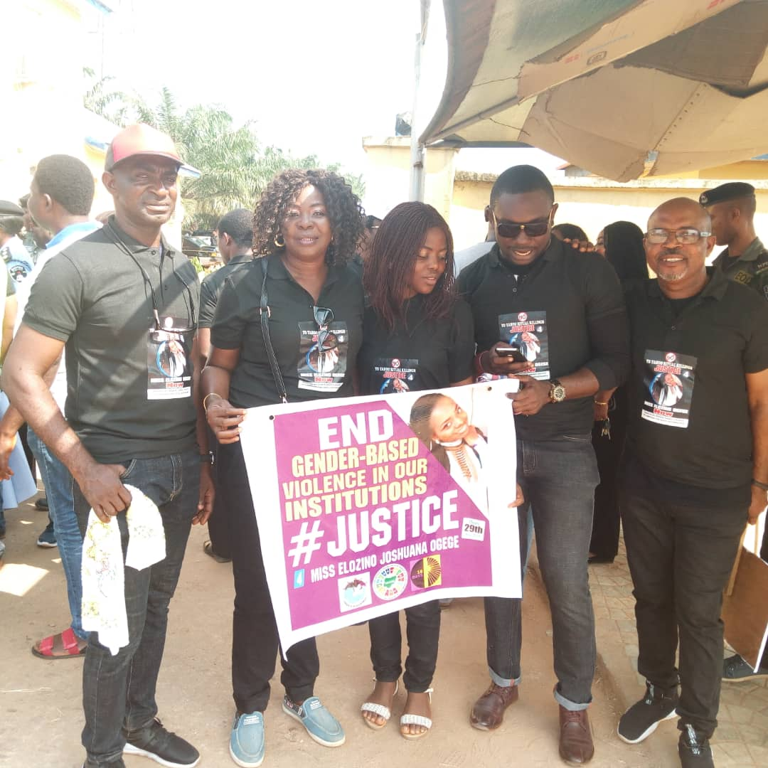

A CALL FOR PROSECTION OF FRIDAY ELURO FOR DEHUMANIZING A WOMAN IN DELTA STATE

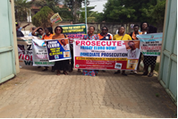

Justice for Queen Clever
Civil Society Advance Forum on Sustainable Development (CAS2030), Demand Justice for Miss Queen who was beheaded in Ozoro town, Delta State by Ritualist for Money ritual. CAS2030
Charge Delta State Police to Carry out Thorough Investigation, and Fish out Queen’s Killer(s).

Justice for Sylvester Oromoni
Civil Society Advance Forum on Sustainable Development issued a statement that was signed by CSOs across Nigeria to the Governor of Lagos State His Excellency Gov. Babatunde Sanwuolu in December 2021 to Demand Justice for Sylvester Oromoni who died as a result of been beaten by Bullies at Dowen College Lagos after the School authority claimed he was injured while playing football. Sylvester Confess that he was beaten Up by Bullies at School and given harmful Substance to Drink.

- Virtual High Level Dialogue On the call for a Ban on Fully Autonomous Weapons
We carried out a Virtual High level Dialogue for the Campaign to Stop Killer Robots in Nigeria in December, 2020.The aim of the Dialogue, to discuss about the dangers of Fully Autonomous Weapons and the role of CSOs and Academia in the call or a preemptive Ban on Killer Robots in Nigeria.

CSOs have carried out / are carrying Sensitization Campaigns in Schools and Community Halls since 2020 to sensitize the General Public on the Dangers of Fully Autonomous Weapons.
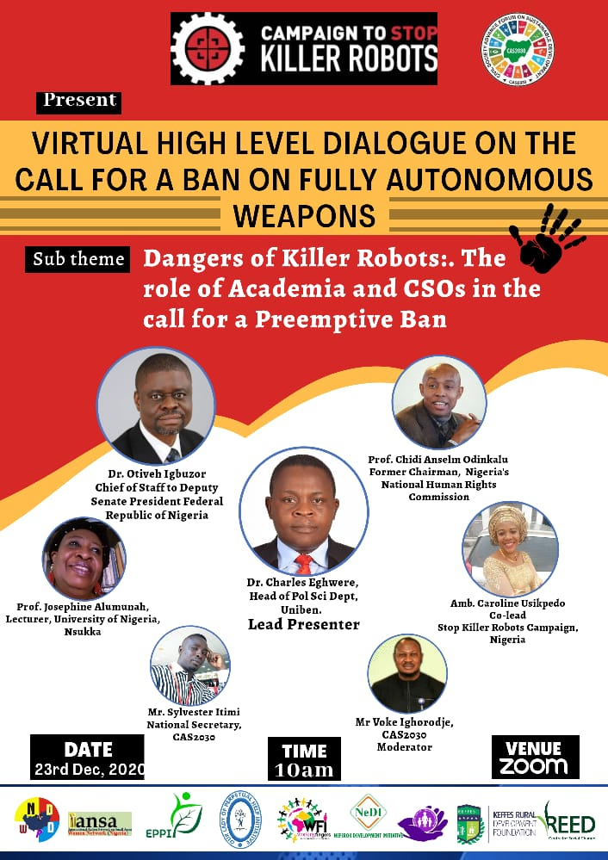

- Virtual Advocacy Meeting with Members
of Parliament on the Call for a Ban on
Fully Autonomous Weapons.
On the 26th, February 2021, Civil Society
Advance Forum on Sustainable Development
held a Virtual Meeting with Member of Parliament
Rt. Hon Francis E. Waive, Member of Federal House
of Representative/ Deputy Chairman House
Committee on Power.
This was to advocate for Why Nigeria Needs to Heed the Call and Join the Negotiations for a Treaty.

Concrete plans to Visit the National House of Assembly was made at the end of the meeting.

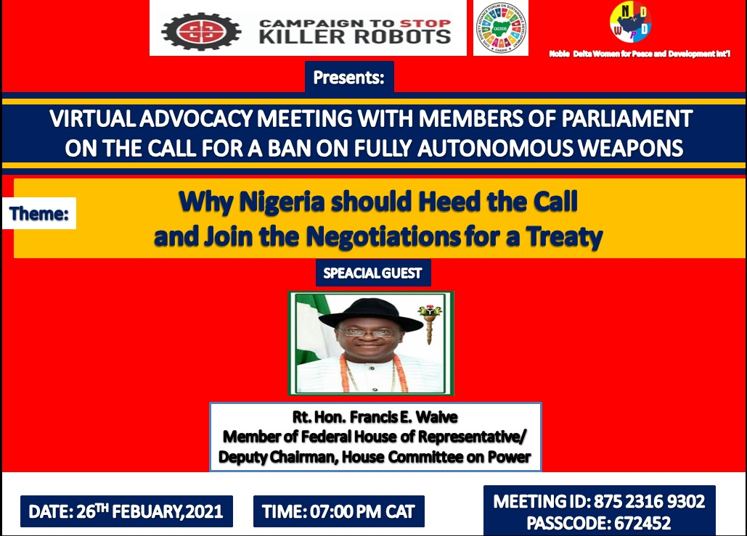

- The stop Killer Robots Campaign in Nigeria:

Awareness Campaign with Young People on
The Dangers of Killer Robots in Delta, Imo and Rivers States
January 2022
CAS2030 through her seed grant, supported
with Echoes Of Love International to visit Otu-jeremi
Secondary School in Ughelli-South, Delta
State to Sensitize Students on the Dangers
of Killer Robots.

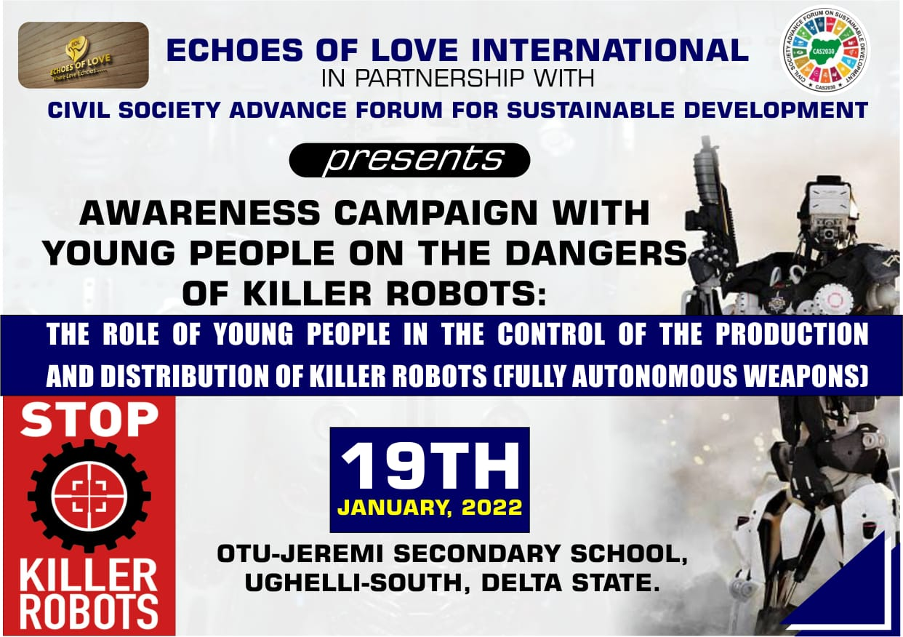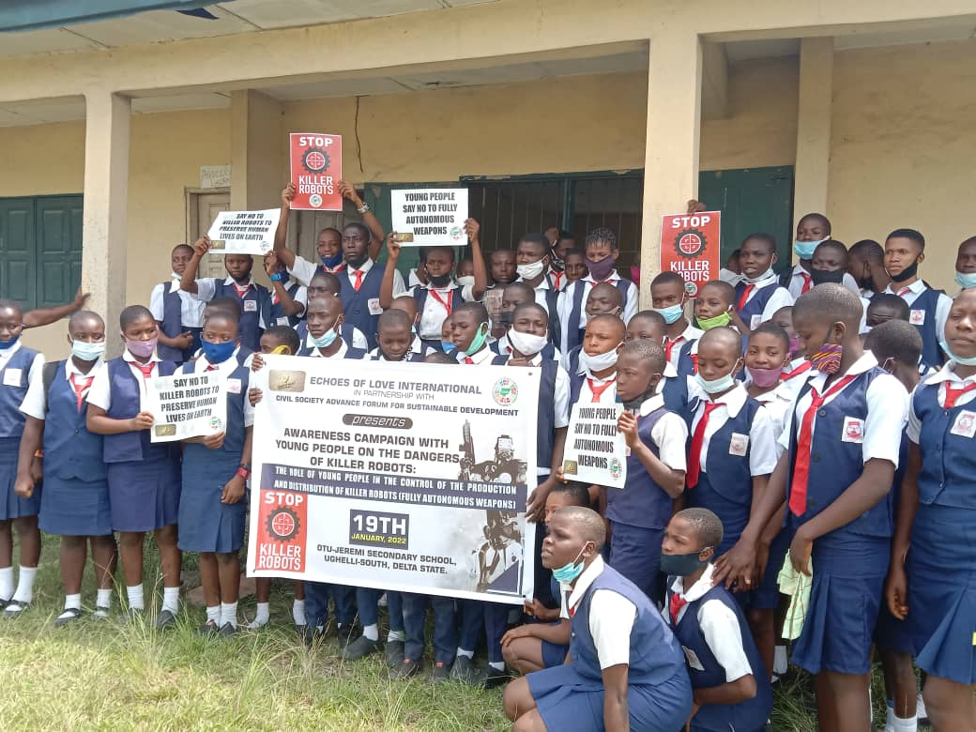
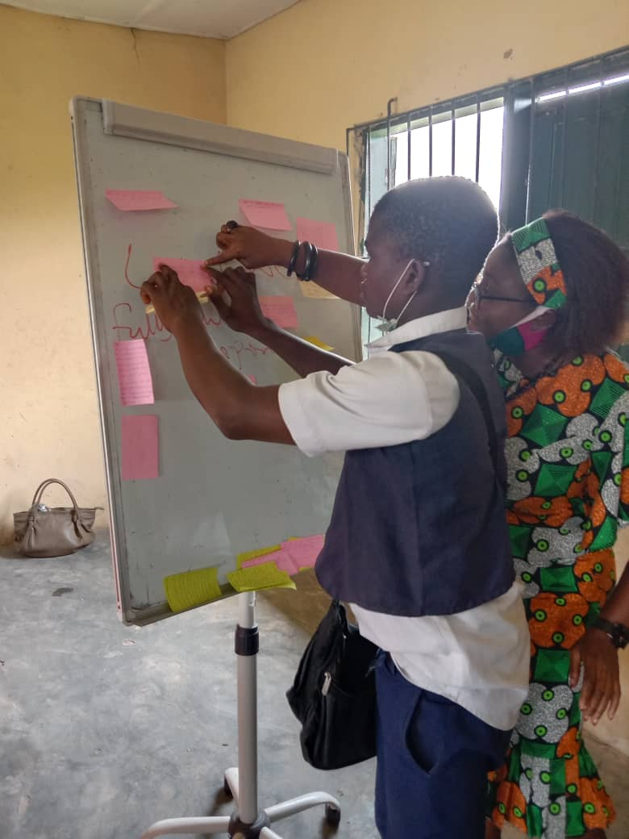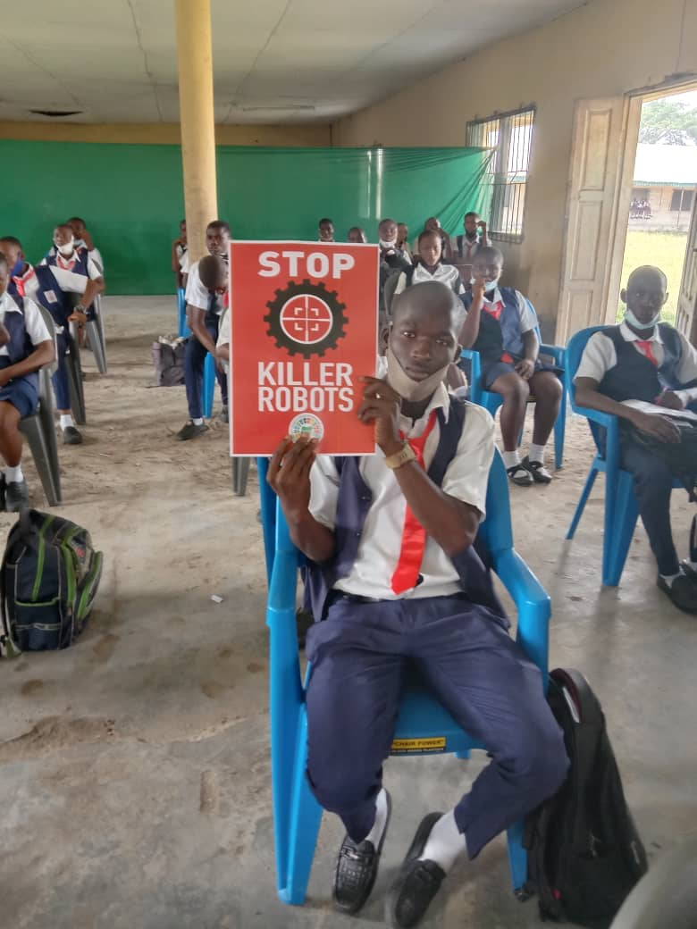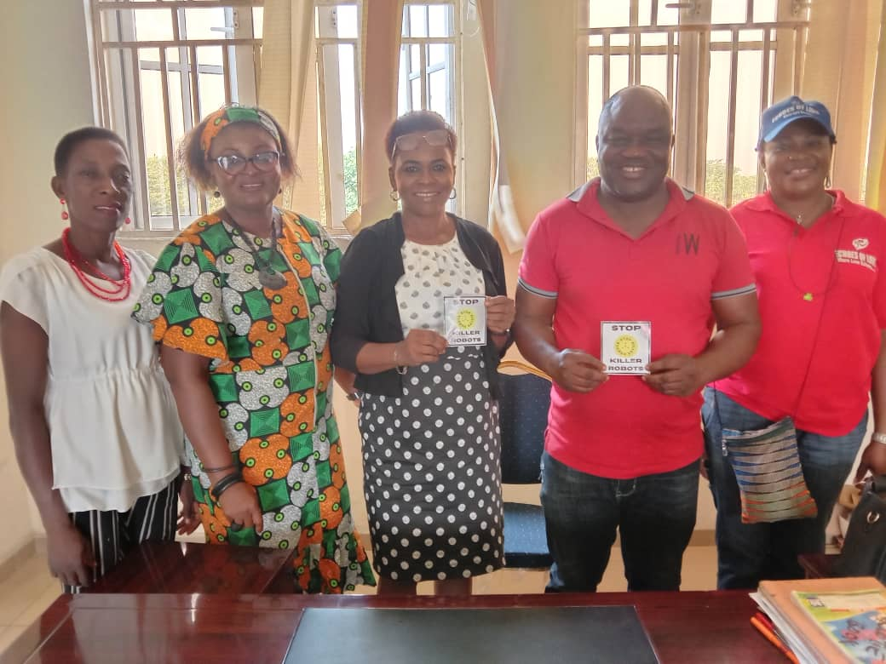

- Awareness Campaign with Students in Uvwie
L.G.A in Delta State 23rd and 24th, January 2022
CAS2030 through her seed grant, supported
with Initiative for Peace and Stability (IPAS) to carry
out Awareness campaign with Student at Army
Day Secondary School.

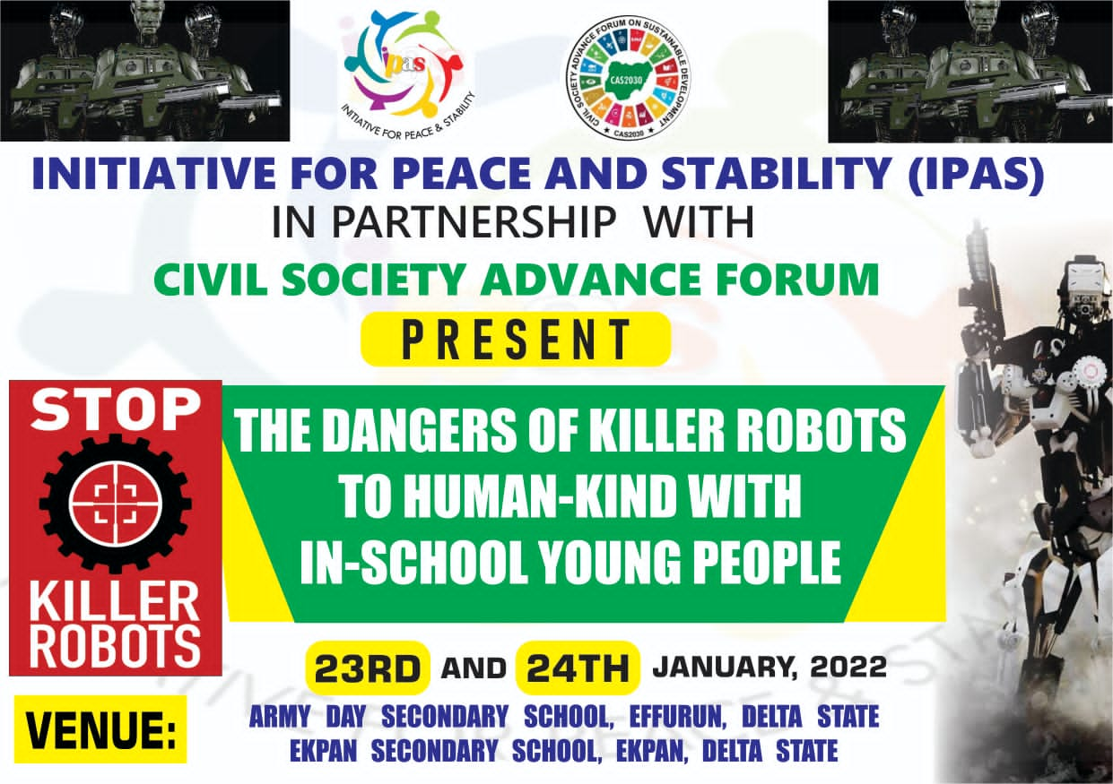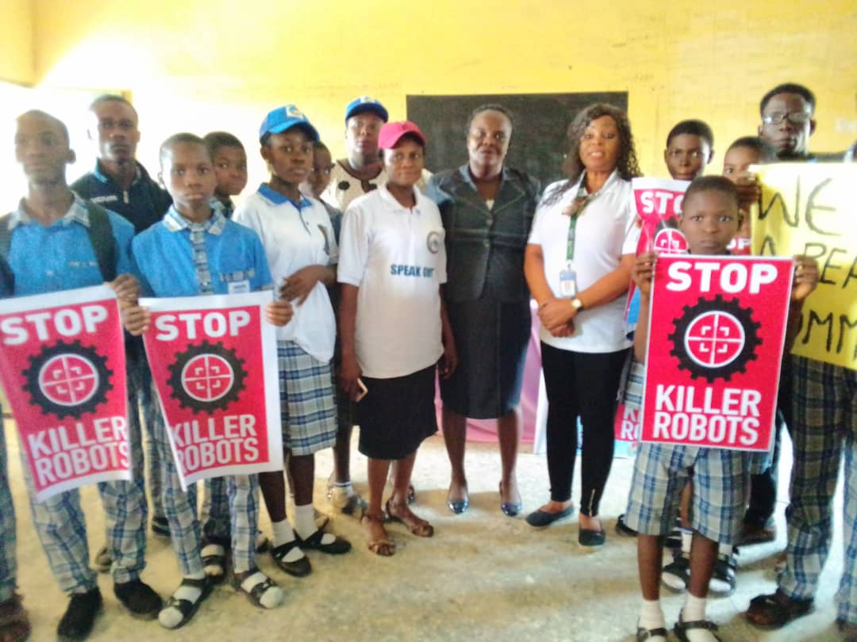

- Awareness Campaign with Students at Rukpokwu Rivers State.
On 21st January, 2022, CAS2030 through her
seed grant, supported Our Lady of Perpetual
Help Initiative to carry out Sensitization on
Students at Community Secondary School
Rukpokwu Rivers State on Killer Robots and
the Dangers of Killer Robots.
.

ORGANIZATIONAL STRUCTURE

Convener:
Noble Delta Women for Peace and Development

Coordinating Council:
Women Environmental Program (WEP)
Kabetkache Women Development
Dave Omokaro Foundation
Nigeria Network of NGOs

Administration:
National Coordinator – Amb. Caroline Usikpedo- Oliseowe
Dep. Nat. Coordinator -Mrs. Loretta Ahokpeme

Board of Trustees
Prof. Lady Roibito Ekanem Samuel
Amb. Caroline Usikpedo-Oliseowe
Comrade Richard Umar Abubakar
Mrs. Bose Agbonmerele Iro-Nsi
Mrs. Badamasi Fatimah Ibrahim
Dr. Okengwu Emeka Fleming

National Executives:
National Secretary – Mr. Sylvester Itimi
National Treasurer – Dr. Eris Jewo-Ibi
National Financial Secretary – Mrs. Eucharia Anekwe
National Organizing Secretary – Mr. Martin Kozah
National Publicity Secretary – Comrd. Augusta Impac Kenebor
National Auditor – Comrade Okpunor Chuks

National Secretariat:
Programs Director- Dr. Ejiro Esiekpe
Program Manager(s) - Mrs. Ayo Okotie
Mr. Salufu Oliseowe

STAFF
Project Manager (Finance /Admin) –
Miss. Rosemary Otomi
Program Officers –
(1) Miss. Endurance Smart
(2) Mrs. Bridget Diemeku

Our Partners
TAP Network
CSR Institute
Civil Society Strategy Group (CSOG) Nigeria

Office:
C/o Noble Delta Women Resource Centre
Building
No. 4 Chris Okonkwo Street, Opposite Living
Faith Church, off Ibusa road, Delta State, Nigeria.
Email: civilsocietyadvanceforum@gmail.com
Telephone : +234-(0) 8068107046
WEBSITE: www.civilsocietyadvanceforum.org

